HYPERLANE
Studio & Production Handbook · Version 1.0

Companion to the Hyperlane Game Design Document v2.2. The GDD defines what is being built. This document defines who builds it, in what order, under whose authority, and on what terms.

1. The Founding Team

Member | Discipline | Role on Hyperlane | Owns
Inkman | Digital illustrator | Creative Director & Game Designer | The GDD, art direction, character and hazard art
Mark | Front-end developer | Client Developer | The Phaser client, gameplay code, the deterministic simulation
Iheoma | Graphic designer | UI/UX & Brand | HUD, menus, shop, leaderboards, brand and marketing assets

1.1 The honest gap
The core team is three people with no game-server engineer and no blockchain developer between them. Stated plainly so that no plan is built on a fiction:
Discipline | Covered by | Status
Game design | Inkman | Covered
Character and hazard art | Inkman | Covered
Client development (Phaser 3) | Mark | Adjacent. TypeScript transfers; Phaser must be learned.
UI, HUD, brand | Iheoma | Covered
Game server, matchmaking, verification | Nobody | Missing. Must be hired or funded.
Soroban / Stellar contracts | Nobody | Missing. Must be hired or funded.
Sound design | Nobody | Missing. Contract per-asset, late.
This is not a problem to solve before starting. It is a problem to solve after P2. The entire game — three classes, all hazards, chain scoring, both single-player modes — can be built by these three people with no server and no blockchain. Only when coins acquire real value does verification become necessary, and by then there is a build worth funding.

2. Roadmap

Each phase ends with something a real person can play or a real reviewer can evaluate. Nothing is built ahead of the phase that needs it. The blockchain comes last, deliberately.
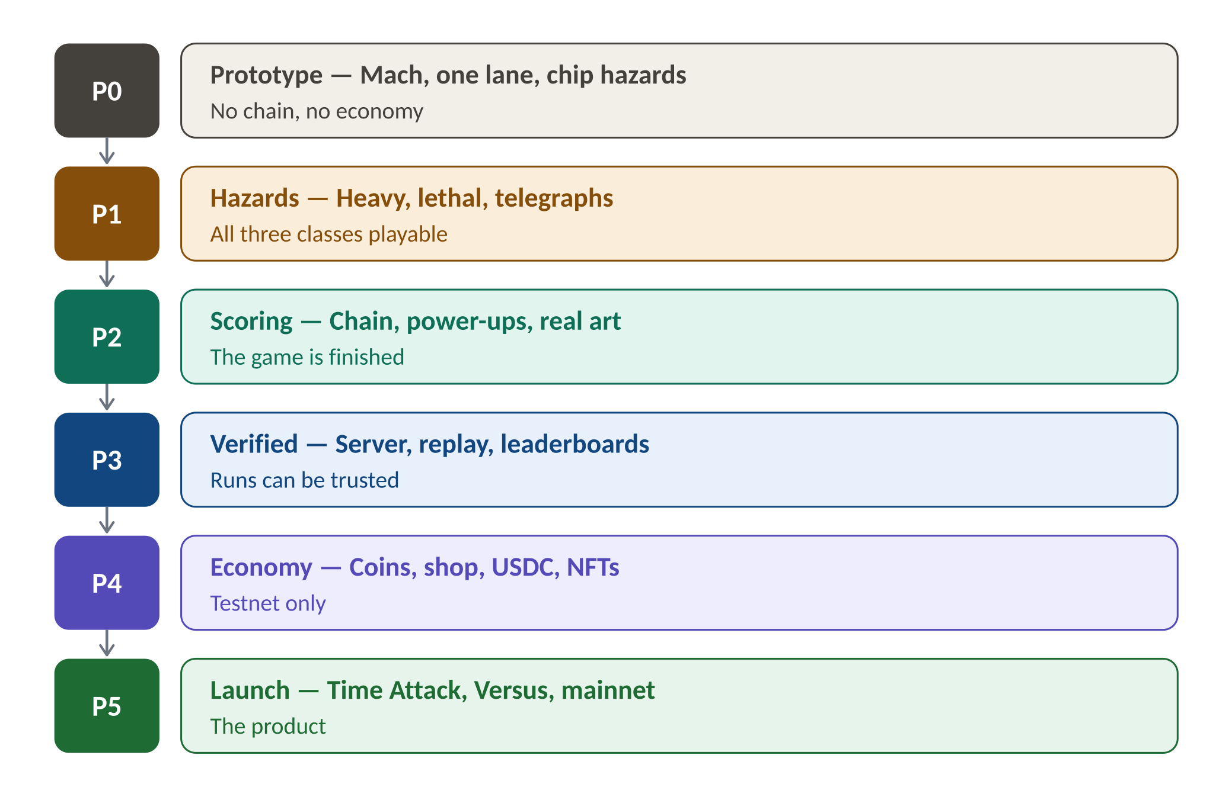
Six phases. The first three require no hires, no server, and no chain.

2.1 Work required, by phase

P0 — Prototype
- Deliverable: Mach running down one procedurally generated lane, clipping chip hazards, in a browser. No chain, no coins, no menu.
- Mark: Phaser 3 project set up. Auto-forward movement, lateral steering, jump, gravity, collision. Fixed-point math from day one.
- Inkman: Placeholder rider and one debris sprite. Close D1 and D8 in the GDD.
- Iheoma: Nothing. Do not design a HUD for a game that does not exist.
- Exit test: Ten people who owe you nothing play it. Do they ask for another go?

P1 — Hazards
- Deliverable: The full hazard set with telegraphs. All three classes playable with their resources.
- Mark: Hazard tiers, damage routing (chassis then rider), telegraph timing, Momentum, Chassis plates, Second Wind. Placeholder audio cue for lethal warning.
- Inkman: Hazard art. Close D2 and D6. Playtest whether Bulwark functions at all.
- Iheoma: First HUD pass — the three resource bars must be legible at speed.
- Exit test: Nobody says "that was unfair" about a lethal death. If they do, the telegraph is wrong.

P2 — Scoring and art
- Deliverable: Chain scoring, power-ups, real art. A finished game with a local leaderboard.
- Mark: Chain logic, multiplier curve, power-up spawning and effects, local high scores.
- Inkman: Final Mach, Brute and Lynn. Bike liveries. Power-up icons.
- Iheoma: Full HUD, menus, character select, leaderboard screen. Chain reset must feel awful.
- Exit test: A playtester can explain their own score without being told how it works.
- Progression: Account Level and Class Mastery are tracked locally. Cosmetic unlocks only. Nothing persists across devices yet, and that is acceptable.
P2 is the milestone that unlocks everything else. It is a complete, shippable game with no blockchain in it. Ship it publicly. It is your SCF application, your tech hub pitch, and your hiring advert simultaneously.

P3 — Verified play
- Requires: A game server engineer. This is the first hire.
- Deliverable: Colyseus server, lane seed authority, deterministic replay, verified global leaderboards. Coins exist as a database balance with no monetary value.
- Core team: Inkman on balance from live data. Mark extracts the shared simulation into a package used by both client and server.
- Progression: Account Level, Class Mastery and XP move server-side. This is the first point at which a player's time is safe.
- Exit test: A tampered client cannot post a score.

P4 — Economy
- Requires: A Soroban developer. This is the second hire.
- Deliverable: Shop, bike upgrades, costumes, USDC purchase, character NFTs. Testnet only.
- Blocking: Legal review of the one-way coin position before any mainnet transaction. See GDD 15.3.
- Exit test: A player can complete Endless mode, fully, with any class, without ever seeing a wallet prompt.

P5 — Launch
- Deliverable: Time Attack, Versus with the Sweeper, mainnet, seasonal leaderboards, sound.
- Requires: Sound designer on contract. QA lead. Community lead.
- Progression: Time Attack track gating goes live. Season Rank begins. Earned characters unlock at Class Mastery milestones.
- Inkman: Earned character art. This is the largest single art commitment in the project and it should be scheduled, not improvised.

3. GitHub Organisation

The organisation cannot be registered until the name question in GDD D13 is resolved. Reserve nothing under "hyperlane".
One organisation. Seven repositories. The naming convention follows the existing house style: a single organisation suffixed with -xyz, and short unprefixed repository names inside it.
Repository | Contains | Visibility | Owner
game-client | Phaser 3 client. Rendering, input, local prediction. | Public | Mark
game-shared | The deterministic simulation and fixed-point maths. Imported by client and server. | Public | Mark
game-server | Colyseus server. Seed authority, replay, verification, matchmaking. | Private until P3 ships | Mark
contracts | Soroban contracts. Character NFTs, USDC settlement. | Public | Core, jointly
art | Sprites, animation, source files. Git LFS. | Private | Inkman
design | GDD, this handbook, decision records, playtest notes. | Public | Inkman
.github | Org profile, issue and PR templates, CONTRIBUTING, CODE_OF_CONDUCT, CLA. | Public | Core, jointly

3.1 Why game-shared exists
The client and the server must run byte-identical simulations or verification silently rejects honest players. The only reliable way to guarantee that is for both to import the same code. Never copy the simulation into two repositories. This is the single most important structural decision in the codebase.

3.2 Why art is private
The code can be open source. The art cannot. Character designs are the asset being sold as NFTs; publishing the source files gives away the only scarce thing in the economy. Public code, private art, is the correct split for a project seeking public-goods funding.

4. Access Control

4.1 Permission tiers
Tier | Who | GitHub role | Can
Owner | Inkman, Mark, Iheoma | Organisation owner | Everything. Add members, change settings, hold keys.
Maintainer | Nobody yet. Promoted hires only. | Write + review | Merge to main after review. Cannot change org settings.
Contributor | Interns, external help, volunteers | Read (fork + PR) | Open pull requests. Cannot merge anything.
Contractor | Paid, scoped, time-limited | Read (fork + PR) | As Contributor. Access revoked at contract end.

4.2 Repository access matrix
Repository | Owner | Maintainer | Contributor | Contractor
game-client | Admin | Write | Fork + PR | Fork + PR
game-shared | Admin | Write | Fork + PR | Fork + PR
game-server | Admin | Write | No access | By exception only
contracts | Admin | Read only | No access | No access
art | Admin | No access | No access | By exception, per asset
design | Admin | Write | Fork + PR | Read
Nobody outside the core team ever receives write access to contracts. Not a trusted intern, not a paid contractor, not a co-founder of a partner studio. The contracts move money.

4.3 Branch protection
- main is protected on every repository. No direct commits. No force pushes. Ever, by anyone, including owners.
- All work arrives by pull request from a branch or a fork.
- One approving review from a core member to merge into game-client, design, or art.
- Two approving reviews from core members to merge into game-shared or contracts. These two repositories decide whether honest runs are accepted and whether money moves.
- CI must pass. Tests, type-checking, and a determinism check that replays a recorded input log and asserts an identical outcome.

4.4 Secrets and keys
- No secret is ever committed. A secret in git history is a secret that has been published, even after deletion. Rotate immediately.
- Testnet keys live in GitHub Actions secrets. Owners only.
- Mainnet signing keys never touch GitHub. They live on hardware wallets held by the three core members.
- Mainnet deployment requires two of three core signatures. No single person, including the founder, can move funds or deploy a contract alone.
- Access is revoked the day someone leaves — not the week after, not when it is convenient.

5. Working With External Help

Interns, volunteers, contract artists, tech-hub placements and hired engineers are all valuable and all governed by the same rules. The rules exist to protect them as much as the project: nobody should discover the terms of their contribution after they have made it.

5.1 Before anyone writes a line
- They sign the Contributor Licence Agreement. It assigns copyright in their contribution to the company. No CLA, no merge. No exceptions for friends.
- They receive a scoped issue. A named GitHub issue with a definition of done. "Help with the game" is not a scope.
- They are told, in writing, what they receive. Payment, credit, or both. Never equity, and never a suggestion that equity might follow.
- They are told who reviews their work and how long review will take.

5.2 Contribution rules
Rule | Reason
Fork and pull request. No branch on the main repository. | Keeps the repository clean and the permission model simple.
One issue, one pull request. | Reviewable work. A 2,000-line PR is a PR nobody reads.
No AI-generated art may be merged into art without written disclosure. | The character designs are the NFT. Provenance must be defensible.
No dependency added without a core review. | Every dependency is a supply-chain risk and a licence obligation.
No contribution to contracts from outside the core team. | The contracts move money.
Every contributor is named in CREDITS.md. | Credit is free, permanent, and owed.

5.3 Paying people
- Prefer paying to promising. A small payment now is worth more to a contributor, and costs the company far less, than equity later.
- Scope, price, deliver, pay, close. Per-asset for art. Per-milestone for engineering.
- If you cannot pay, say so before they start and offer credit, portfolio rights, and a reference. Many people will accept that. Nobody accepts it retroactively.

6. Founders and Everyone Else

This is the most important section in this handbook, and the one most likely to be tested by circumstance. Write it down now, while the question is theoretical and nobody is angry.

6.1 What makes someone a founder
Four things, together. Not three. Not any one of them alone.
 | Founders | Everyone else
Decision rights | Can close an open decision in the GDD | Can propose, cannot decide
Ownership | Holds equity, subject to vesting | Holds none, and is told so in writing
Keys | Holds a mainnet signing key and org ownership | Holds neither
Liability | Named on the company registration; personally responsible | Not named; not responsible
Notice what is not on that list: how much code someone wrote, how good they are, or how much you like them. A brilliant contributor who ships more than you do is still not a founder. Founding is a legal and historical position, not a performance ranking. It is not withheld as a judgement on anyone.

6.2 The idea, and what it is worth
Hyperlane came from one person's head. That fact deserves to be recorded honestly, and it deserves not to be confused with something it is not.
- Creator credit is permanent and non-negotiable. "Created by Inkman" appears in the credits, on the store page, and in every version of this document, in perpetuity. It survives departure. It cannot be diluted, sold, or voted away.
- Creative authority is a real, separate thing. The Creative Director holds a casting vote on design questions — what the game is. This is not a general veto. It does not extend to money, hiring, equity, or contracts.
- Equity is not paid for the idea. It is paid for years of work delivered under risk. Every idea is worth precisely nothing until somebody builds it, and the three of you are building it together.
Founders who conflate "I had the idea" with "I own the company" destroy their teams, usually in year two, usually over something small. Separating creator credit from creative authority from equity is how you keep all three of them intact.

6.3 Vesting
- All three founders vest. Including the founder who had the idea. Four years, one-year cliff.
- Nobody holds unvested equity outright. A founder who leaves in month eight leaves with nothing but their credit — which is permanent.
- All founders assign their pre-existing IP to the company on registration. The GDD, the art, the code, the name. Otherwise the company owns nothing it is selling.

6.4 Founders are a closed set
Founder status is not a rank, not a reward, and not achievable. It is a description of who was present when there was nothing to be present for. A person who joins in year two did not take the year-one risk and cannot retroactively have taken it. This is not a slight. It is a fact about time.
- Nobody becomes a founder. The set is Inkman, Mark and Iheoma. It closed the day the company was registered.
- This creates a real problem and it requires a real answer. The server engineer hired at P3 may become the most important person in the codebase. If founders are the only people who hold equity, that engineer has no upside and will leave.

6.5 The option pool
The structure that resolves it, and the reason to reserve it at registration rather than when it becomes urgent:
 | Founders | Option pool holders
Who | Inkman, Mark, Iheoma. Closed. | Key hires, at the founders' discretion. Open.
Holds equity | Yes, subject to vesting | Yes, subject to their own vesting
Holds keys | Yes | No
Decision rights | Yes | No
Named on registration | Yes | No
Reserved share | — | 10 to 15 per cent of the company, set aside at registration
Founding is an origin story, not a job title. The option pool is how you hire brilliant people and pay them properly in ownership without pretending they were there at the beginning. Reserve it before you need it; carving it out later means diluting yourselves under pressure.

7. Immediate Actions

# | Action | Owner | Blocks
1 | Resolve the project name (GDD D13) | Inkman | GitHub org, domain, CAC
2 | Register the organisation and the seven repositories | Founders | All work
3 | Sign founder IP assignment and vesting agreements | Founders | Any funding conversation
4 | Write CONTRIBUTING.md and the CLA into .github | Inkman | Any external help
5 | Reserve a 10-15% option pool at registration | Founders | Hiring at P3
6 | Mark completes a Phaser 3 tutorial project, start to finish | Mark | P0
7 | Close GDD decisions D1 and D8 | Inkman | P0
8 | Build P0 | Mark | Everything
9 | Playtest P0 with ten strangers | Founders | Tech hub pitch

The honest first milestone is Mach running down one lane, clipping one piece of debris, in a browser. No server. No wallet. No coins. Nothing on this page matters until that exists.

